Name | Singh Suryansh Alok Kumar
UID no. | 2022300119
Experiment No. | Week 3 day 1

AIM: | Problem Solving Using Object Oriented Programming
Program 1
PROBLEM STATEMENT : | Implement Calculator (Menue driven - switch case)
THEORY: | Switch- Case:  In Java, the switch statement is used to evaluate a variable or expression against a set of values and execute a block of code based on the matched value. It is commonly used as an alternative to a series of "if-else" statements.  Constructor:  In Java, a constructor is a special method that is used to create and initialize objects of a class. It is called automatically when an object is created and is used to set the initial values of the object's member variables.  Here are some key concepts to keep in mind about constructors in Java:  - Constructor name: The name of the constructor is always the same as the name of the class.  - No return type: A constructor does not have a return type. This is because the main purpose of a constructor is to create and initialize an object, not to return a value.  - Overloading: Constructors can be overloaded, which means that you can define multiple constructors with different parameter lists. This allows you to create objects with different initial values depending on the arguments passed to the constructor.  - Default constructor: If you do not define any constructors for a class, Java will automatically provide a default constructor with no arguments. However, if you define any constructors explicitly, the default constructor will not be created unless you define it explicitly.  - Access modifiers: Constructors can have access modifiers (public, private, protected) to control the visibility of the constructor to other classes.  - Initialization of member variables: The purpose of a constructor is to set the initial values of the object's member variables. This is usually done using parameters passed to the constructor or by assigning default values to the member variables.  - Chaining constructors: In Java, you can call one constructor from another constructor using the "this" keyword. This is called constructor chaining and is used to avoid code duplication when defining overloaded constructors.  Overall, constructors are an important part of object-oriented programming in Java, as they are used to create and initialize objects with the appropriate initial values. By understanding the key concepts of constructors, you can create classes that are flexible and easy to use in your Java programs.  Do-While Loop:  A do-while loop is a type of loop in Java that allows you to repeatedly execute a block of code as long as a certain condition is met. The difference between a do-while loop and a while loop is that a do-while loop executes the code block at least once before checking the condition, whereas a while loop checks the condition first before executing the code block.
PROGRAM: | //Importing required java classes  import java.util.*;  //Main class  public class Calculator{  public static void main(String[] args){  int b=0;  int s=0;  int temp=0;  Scanner sc=new Scanner(System.in);  //Creating a object of the operation class  operations op= new operations();  //Displaying menue options  do  {  System.out.println("Enter a number");  int p=sc.nextInt();  System.out.println("Enter another number");  int q=sc.nextInt();  //Sorting the Input numbers to larger and smaller  if(p>q)  {  b=p;  s=q;  }  else  {  b=q;  s=p;  }  System.out.println("Press 1 to add the 2 numbers");  System.out.println("Press 2 to subtract the 2 numbers");  System.out.println("Press 3 to multiply the 2 numbers");  System.out.println("Press 4 to Divide the 2 numbers");  System.out.println("Press 5 to find the remainder the 2 numbers");  //Intializing Switch case  int a=sc.nextInt();  switch(a)  {  case 1:  //ADDITION  op.add(b,s);  break;  case 2:  //SUBTRACTION  op.sub(b,s);  break;  case 3:  //MULTIPLICATION  op.mult(b,s);  break;  case 4:  //DIVISION  op.div(b,s);  break;  case 5:  //REMAINDER AFTER DIVISION  op.rem(b,s);  break;  //For invalid input  default :  System.out.println("Enter a valid number");  }  System.out.println("Press 1 to contineu: ");  temp = sc.nextInt();  }  while(temp==1);  //Repeating till the user inputs any number other then 1  sc.close();  }  }  //Opration class consisting of all the arithmatic operations and displaying the results  class operations{  public void add(int x,int y)  {  System.out.println("The Sum of the 2 numbers is: "+ (x+y));  }  public void sub(int x,int y)  {  System.out.println("The Magnitutde of Difference of the 2 numbers is: "+ (x-y));  }  public void mult(int x,int y)  {  System.out.println("The product of the 2 numbers is: "+ (x*y));  }  public void div(double x,double y)  {  System.out.println("The Division of the 2 numbers is: "+ ((double)x/y));  }  public void rem(int x,int y)  {  System.out.println("The Remainder of the 2 numbers is: "+ (x/y));  }  }
RESULT:
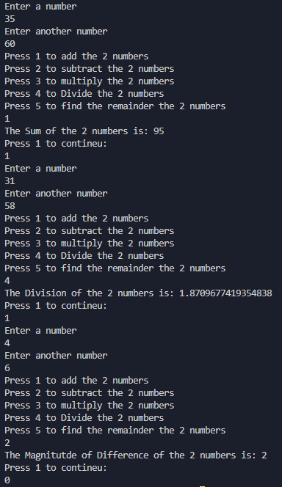
Program 2
PROBLEM STATEMENT : | Create a Test class with a data double base, int power, int logBase, int argument.  Create a default, no-argument constructor which sets the default value of all variables to 2.  There are 2 overloaded functions:  1. double calculate (double base, int power)  This function returns the value when *base* is raised to *power*  For example: calculate (3.0, 2) returns the value of 3.0 raised to 2 i.e., 9.0  2. double calculate (int logBase, int argument)  This function returns the value of the log of *argument* to the base *logBase*.  For example: calculate (3, 9) returns log of 9 to the base 3 i.e., 2.0  Create a main method in a separate class to call the above functions with the following inputs:  1. calculate (2, 4)  2. calculate (2.0, 4.0)  Create a display() method which displays the output based on the type of Test object created.
THEORY: | Method Overloading:  Method overloading is a feature in Java that allows you to define two or more methods with the same name in the same class. The methods must have different parameter lists (the number, type, or order of the parameters). Java uses the parameter list to determine which version of the method to call when the method is invoked.  Constructor Overloading:  In Java, constructor overloading is a technique where multiple constructors can be defined for a class, with each constructor taking a different set of parameters. This allows objects of the same class to be created in different ways, depending on the arguments passed to the constructor.  Constructor overloading is similar to method overloading, where multiple methods with the same name can be defined in a class, but with different parameter lists.  example, the Person class has three constructors:  - The first constructor has no parameters and sets the name to "Unknown" and the age to 0.  - The second constructor takes a name parameter and sets the name to the value of the parameter, and the age to 0.  - The third constructor takes both name and age parameters and sets the name and age to the values of the parameters.
PROGRAM: | //Importing required java classes  import java.lang.Math;  //Main Class  public class LogAndPower {  public static void main(String[] args) {  Test test = new Test();  //Constructor Overloading  double power = test.calculate(2.0,4);  test.display(power);  double log = test.calculate(2,4);  test.display(log);  }  }  class Test {  private double base;  private int power;  private int logBase;  private int argument;  //Assigining values to variables  public Test() {  power=2;  base=2;  logBase=2;  argument=2;  }  //Calling with 1 double and 1 int parameter  public double calculate(double base, int power) {  System.out.print("The value when " + base + " is raised to " + power + " = ");  return Math.pow(base,power);  }  //Calling with 2 int parameter  public double calculate(int logBase, int argument) {  System.out.print("The value of the log of " + argument+ " to the base " + logBase + " = ");  return (Math.log(argument)/Math.log(logBase));  }  public void display(double ans) {  System.out.print(ans + "\n");  }  }
RESULT:
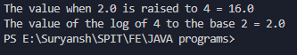
Program 3
PROBLEM STATEMENT: | Write a program to Generate a random number between 0 to 20
THEORY: | Math.Random:  Math.random() is a method in Java that returns a pseudo-random number between 0.0 and 1.0. The number returned is a double-precision floating-point value, and it is generated by a deterministic algorithm that produces a sequence of numbers that appear to be random. The Math.random() method is part of the java.lang package, which means that it is available to all Java programs by default.  This will generate a random number between 0.0 (inclusive) and 1.0 (exclusive)  random() creates a doube between 0 and 1 so to get in range of 0to 20 we multiply it by 20 and then typecast it to int
PROGRAM: | //Importing required java classes  import java.lang.Math;  //Main Class  public class Random{  public static void main(String[] args)  {  //random() creates a doube between 0 and 1 so to get in range of 0to 20 we multiply it by 20 and then typecast it to int  double rand= Math.random();  System.out.println("The random number is: " + (int)(rand*20));  }  }
RESULT:
